**What is Salesforce?**  
Salesforce provides software and services aimed at creating relevant customer experiences. Businesses can use Salesforce services to better connect with partners, customers, and potential. Companies can track customer activity, market to customers, and perform many other tasks using Salesforce CRM customers.

**What are the services provided by Salesforce?**

* SAAS (Software-as-a-Service)
* PAAS (Platform-as-a-Service)
* IAAS (Infrastructure-as-a-Service)

Sign up to the Salesforce using the following link:

[**https://developer.salesforce.com/signup**](https://developer.salesforce.com/signup)

After signing up go to **Setup** and click on **Developer Console**.

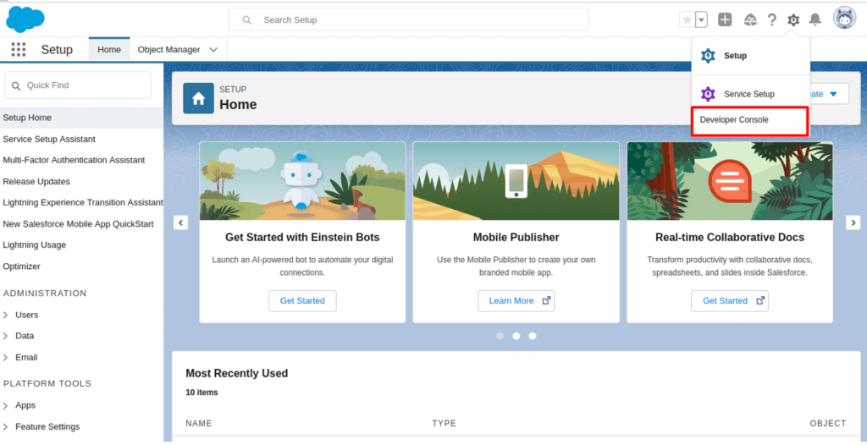

Now, in Developer Console click on **File** -> **New** -> **Apex** **Class** and Name it as **Demo1**

**Note:** If your **Apex Class is disabled** then signup through the given link: **https://developer.salesforce.com/signup**

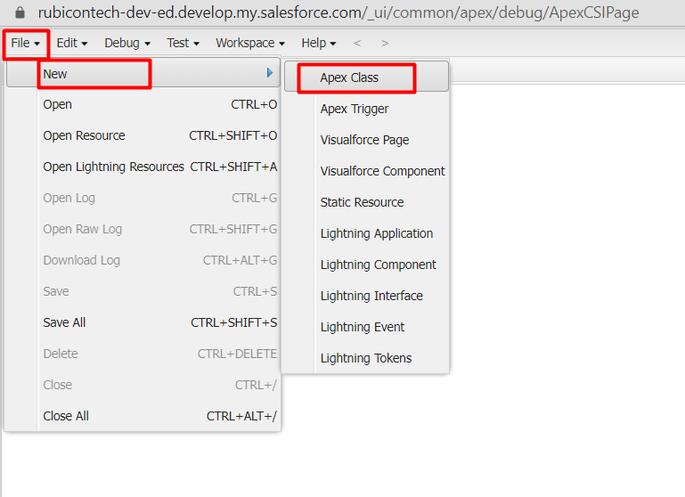

##### **1. Write the code to create an account.**

Do not forget to save it.

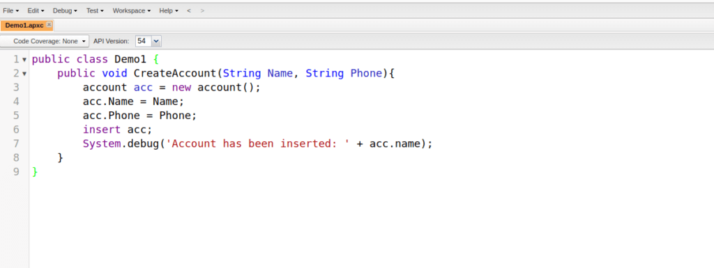

Click on **Debug** ->**Open Execute Anonymous** **Window** and write the code and then **Execute** it.

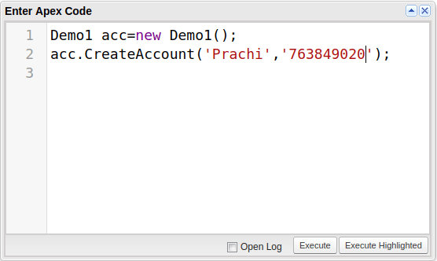

You can see the record has been successfully added.

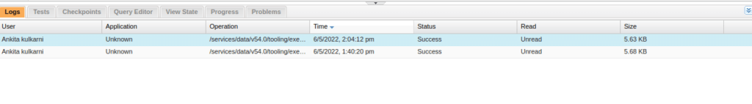

Similarly, you can add number of records. To retrieve the records go to **Query Editor** and type the query language and **Execute** it.

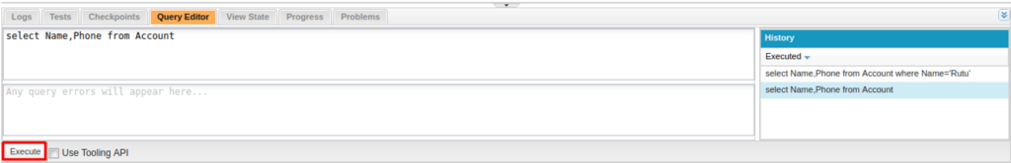

You can see the records added.

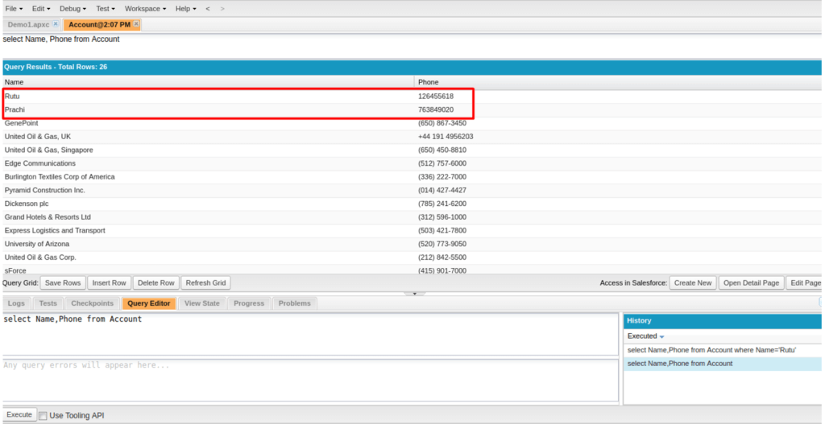

##### 2. **Write the code to update the account.**

Follow the same steps: **File** -> **New** -> **Apex** **Class** and name it as **Demo2**.

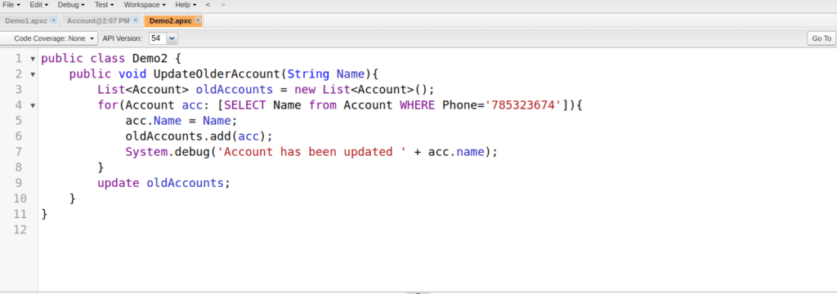

Again click on **Debug** -> **Open** **Execute** **Anonymous** **Window**and write the code.

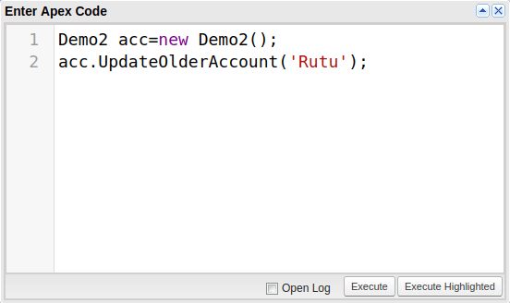

To view the records in Salesforce

##### 3. **Write the code to delete the records.**

Follow the above steps: **File** -> **New** -> **Apex** **Class** and name it as **Demo3**.

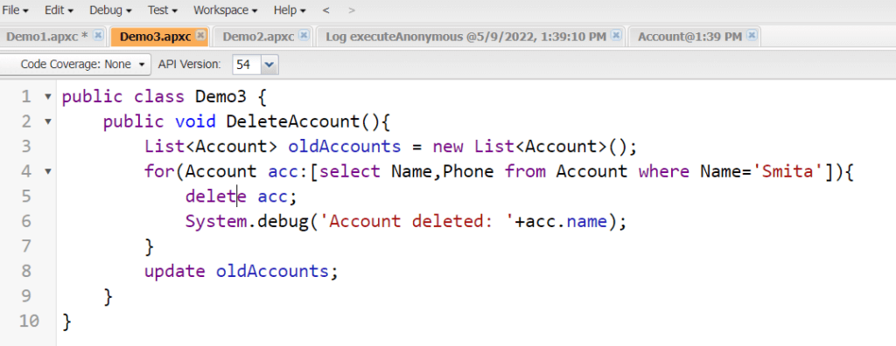

Again click on **Debug** -> **Open** **Execute** **Anonymous** **Window**and write the code.

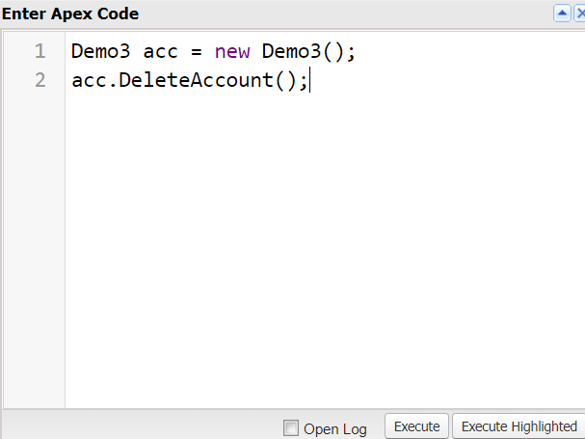

To view the records in Salesforce go to **Setup** and search for **Accounts** and click on it.

